About the Operator Console
Operator Console is a specialized version of Interaction Desktop designed specifically for receptionists, company operators, contact center dispatchers, and other personnel who direct many calls. Along with the standard features in Interaction Desktop, Operator Console users have specific functionality tailored to their needs.
You can quickly identify whether you are using Operator Console. The words "Operator Console" appear in the window title in Interaction Desktop.

Operator Console Rapid Transfer
Operator Console users have access to two quick and easy ways to transfer calls. Operator Console users can also employ any of the standard methods for transferring a call.
Note: Be sure that the appropriate view has focus. A tab with its name in bold type indicates the view with focus This is the view that receives keyboard input. When transferring calls, verify that the view containing the call has focus before typing the extension or phone number.

Transfer a call by typing a name or number
- Select a call and start typing the extension or phone number to which you want to transfer the call. The Transfer dialog box opens with a drop-down list of choices.
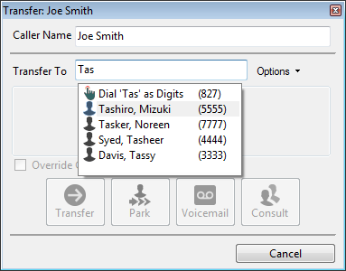
- From the drop-down list, select either Dial [your entry] as Digits to convert a text entry into numbers, or select the appropriate name and associated extension number.
- Optionally, if you select a CIC user as a recipient, you can select or clear the Override Call Forwarding check box. If selected, CIC disregards any forwarding phone number set for the CIC user. If cleared, CIC transfers the call to the extension or phone number currently preferred by the CIC user.
4. Click Transfer.

Transfer by selecting a directory entry
Select a call, then select a directory entry and press Enter. This action transfers the selected call to the phone number or extension for the selected directory entry.
Operator Console
keyboard shortcuts
Interaction Desktop reserves these shortcut features for Operator Console users:
Shortcut | Example
Press Enter to switch a connected or alerting call between connected and hold states. | You can press Enter to answer a call as it comes into My Interactions. After you have answered, you can press Enter to put the call on hold, and then press Enter again to reconnect.
Press Enter within a directory to transfer a selected call to a selected directory entry. | Continue to select a call, select a directory entry, and press Enter. The call transfers to the default phone number for the selected directory entry.
Press Shift + Enter to dial the default number for the currently selected directory entry. | Select a directory entry or personal contact, then press Shift+Enter to call that person at their default phone number.
Operator Console Call Transfer
shortcut keys
Interaction Desktop reserves Call Transfer Shortcut Keys for Operator Console users with the necessary Security and Access Control rights. However, all users can employ the standard shortcut keys available in Interaction Desktop.
Transferring a call without speaking to the intended recipient is a blind transfer. Use a blind transfer if you do not need to speak with the recipient before transferring the call. If the intended recipient does not answer, the call goes to the recipient’s voice mail.
Transferring a call after speaking with the intended recipient is a consult transfer. Use a consult transfer to speak to the recipient before you transfer the call.
To use any of the following shortcut keys:
1. Select a connected call (or a call on hold).
2. Select the appropriate directory entry.
3. To transfer the call to one of the alternate configured numbers for the user, press the shortcut key combination.
Or press Enter to use the rapid transfer feature to forward the call.
Example: To transfer a currently selected call to a user’s mobile phone after talking to the intended recipient, select the recipient’s directory entry, press and hold Ctrl and Shift, then press I.

Transfer to | Without Consulting | After Consulting
Assistant | Ctrl+Alt+N | Ctrl+Shift+N
Business | Ctrl+Alt+B | Ctrl+Shift+B
Business 2 | Ctrl+Alt+U | Ctrl+Shift+U
Fax | Ctrl+Alt+F | Ctrl+Shift+F
Home | Ctrl+Alt+H | Ctrl+Shift+H
Home 2 | Ctrl+Alt+O | Ctrl+Shift+O
Mobile | Ctrl+Alt+I | Ctrl+Shift+I
Pager | Ctrl+Alt+G | Ctrl+Shift+G

Operator Console Whisper Mode
Interaction Desktop reserves Whisper Mode for Operator Console users. If they have the appropriate rights, other users can employ the supervisory Coach feature.
To add yourself to an agent’s interaction on any queue you have permission to monitor, use Whisper mode. Whisper mode enables you to talk to the agent without the customer knowing. The agent can hear your side of the conversation, but the customer cannot.
Tip: If the agent presses the Mute button while you are "coaching" the agent, the customer no longer hears the agent but the agent can continue to converse with you. The Mute button does not affect the audio between the agent and the coach.

To coach an agent on an interaction:
1. Make sure that you have permission to monitor a specific queue.
2. Select the interaction you want to join and click the Whisper button or press Ctrl+W.
Result: The Listen button activates. If the agent has the appropriate rights, an icon appears in the agent’s Lstns column in My Interactions.
Note: You now connect to the agent’s interaction, enabling you to convey information to the agent without the other party knowing. The agent can hear your side of the interaction, but the other party cannot.
Tip: To disconnect the session, click the Listen button.

Advanced user tips and shortcuts
Interaction Desktop contains shortcuts for frequently performed tasks.
Note: These shortcuts work only if you select an interaction or view before you use a shortcut. A view must have focus before you use the shortcut keys. A tab with its name in bold type indicates the view with focus.
For shortcuts to work properly, hold down the Ctrl or Alt key while pressing and releasing the second and then, if needed, the third key.

Interaction functions

Shortcut | Function | Shortcut | Function
Ctrl+B | Callback | Ctrl+D | Disconnect
Ctrl+P | Pickup | Ctrl+J | Join
Ctrl+H | Hold | Ctrl+L | Listen In
Ctrl+U | Mute | Ctrl+R | Record
Ctrl+T | Transfer | Ctrl+E | Pause
Ctrl+K | Park Orbit | Ctrl+I | Private
Ctrl+M | Voicemail | Ctrl+N | Assistance
Ctrl+Shift +P |  | Properties
Ctrl+Shift +R |  | Remove from Queue

Menu shortcuts

Shortcut | Function
Alt+F+O | Log off
Alt+F+S | Change Station
Alt+F+C | Close (hide) the Interaction Desktop
Alt+F+X | Exit
Ctrl+Shift+N | Create a new View
Alt+R+C | Create a new Workspace
Alt+O+C | Configuration

More keyboard tips
The Winkey is the Windows logo key typically located between the Ctrl and Alt keys.
- To place Interaction Desktop on top of any other running Windows applications, in Windows 8, press WinKey+N. In previous Windows versions, press WinKey+C. If an interaction is in your queue, the focus is on My Interactions.
- To expand Interaction Desktop to full-screen mode, press Winkey+up arrow. To restore it to its previous size, press Winkey+down arrow.

Interaction Desktop basics
The following sections describe features that are available to all Interaction Desktop users. They are particular interest to users new to Interaction Desktop who direct and manage large numbers of interactions.

Create workspaces and add views
You can create custom workspaces to contain different views. These views can relate to one specific task such as managing calls or emails. If you no longer need a custom workspace, you can delete it.

Create a custom workspace
- Do one of the following.
- Click the down arrow to the right of the New button and select Workspace.
- Select Workspaces > Create Workspace.
- In the Create New Workspace dialog, type a Name and Description, and then select an Icon for the workspace.
- Click OK.

Add views
You can add views like My Interactions or the Company Directory to custom workspaces. You can add the same view to multiple workspaces.
- Open the workspace to which you want to add a new view and do one of the following:
- Click File > New > View.
- Click the down arrow to the right of the New button and select View.
- Press the shortcut keys Ctrl+Shift+N.
- In the Create New View dialog box, locate and select the view you want to add to the workspace and click OK.

Manage status

Set your status
Do one of the following:
- Select a status from the My Status drop-down list.
- In the notification area of your taskbar (at the lower right side of your main window), right-click your status icon.
- Click a Fast Status button.
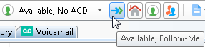

Manage phone calls

Make a new call
Type a number in the Enter a Name or number to dial drop-down list and press Enter or select a number from the list.
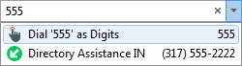

Dial a recently dialed number
Do one of the following:
- Click the arrow at the end of the Enter a Name or number to dial drop-down list. Then click any number in this list of recently dialed numbers.
- In the Call History view, double-click a selected number. Or right-click a number and then click Dial.

Dial a number inside the organization
In the Company Directory, do one of the following:
- Double-click a name in the directory list.
- Click any phone number link and then click Yes at the Dial prompt.
- Right-click a name and click one of the displayed “Dial…” entries.

Conference calls
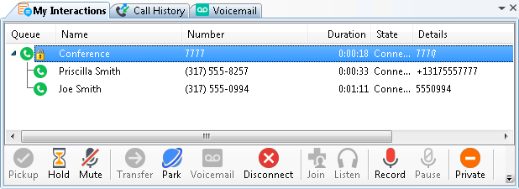

Create a conference call
1. Dial the number of a participant in the conference call, and then click the Hold button to put the call on hold.
2. Repeat step 1 for each participant.
3. Select one of the calls you want to conference and while holding down the mouse button, drag that call to another call in My Interactions and release. You see a new Conference interaction.

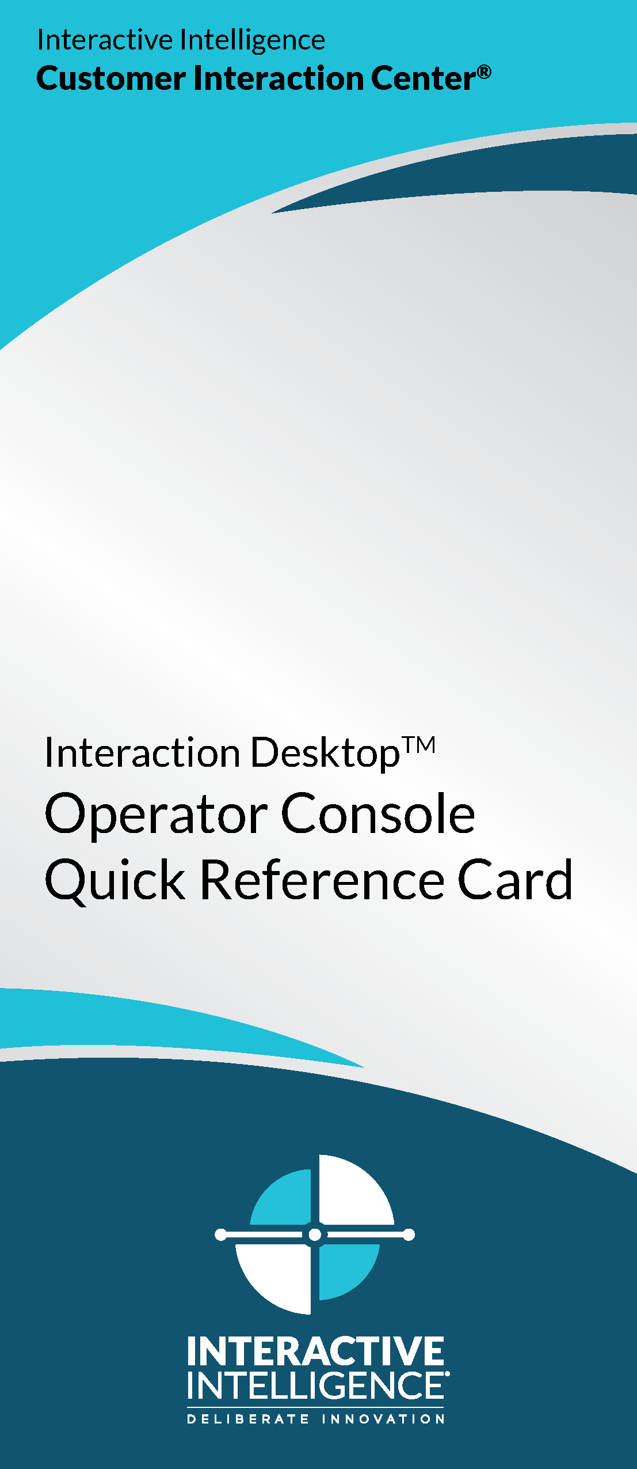
Conference call tips
- To add parties to a conference call, drag a connected call and drop it on the Conference interaction.
- To join a conference call, select the call or conference call you want to join and click the Join button.
- To disconnect someone from a conference call, from the list of joined calls in the conference, choose a participant and click the Disconnect button or right-click and choose Disconnect.

More about Interaction Desktop

Help
- To learn about views and workspaces, click Help > Getting Started.
- To learn more about managing interactions, click Help > Interaction Client.

Online tutorial
Check with your CIC administrator about the availability of an online tutorial that shows you how to use Interaction Desktop.

My Contact Information
Corporate phone number:
My direct number:
My extension:
My password:
My email address:
Other:

Copyright 1997–2015
Interactive Intelligence, Inc.
7601 Interactive Way
Indianapolis, IN 46278
Telephone/Fax: (317) 872-3000
www.ININ.com
DC-012-4.0-QRID2
Revised May 4, 2015
Applies to CIC 2015 R4 or later

